SUMMER JOBS

The holiday season is almost upon us and for young people that means Christmas casual jobs! Due to the increase in business, many organisations employ casuals to make up the shortfall in their staff. This is great news for young people as it’s the perfect time to apply for your first job, or even have a second one.

YOUTH CENTRAL WEBSITE

Before you start applying for jobs, create a resume or ensure your current one is up to date. The Youth Central website has excellent resume and cover letter templates and tips on interviews, www.youthcentral.vic.gov.au

The following are three organisations that will be employing staff:
Coles

Read about the recruitment process at this link. Here you can create an expression of interest for jobs and indicate whether you will need support through the recruitment process if you have additional needs such as a disability or medical condition,
https://colescareers.com.au/au/en/our-recruitment-process

To search and apply for jobs, go to https://colescareers.com.au/au/ and using the search function look for jobs in your area. If you find one, click apply and follow the steps.

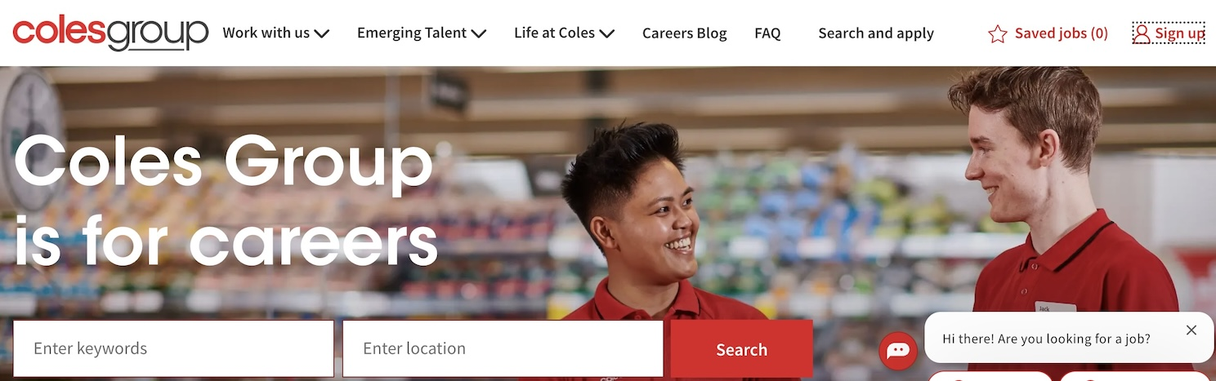

Woolworths Group

Woolworths Group

Woolworths Group includes companies such as Woolworths supermarkets and Big W. To search for jobs, go to www.wowcareers.com.au and use the search function to look for jobs in your area. If you find one, click apply and follow the steps.

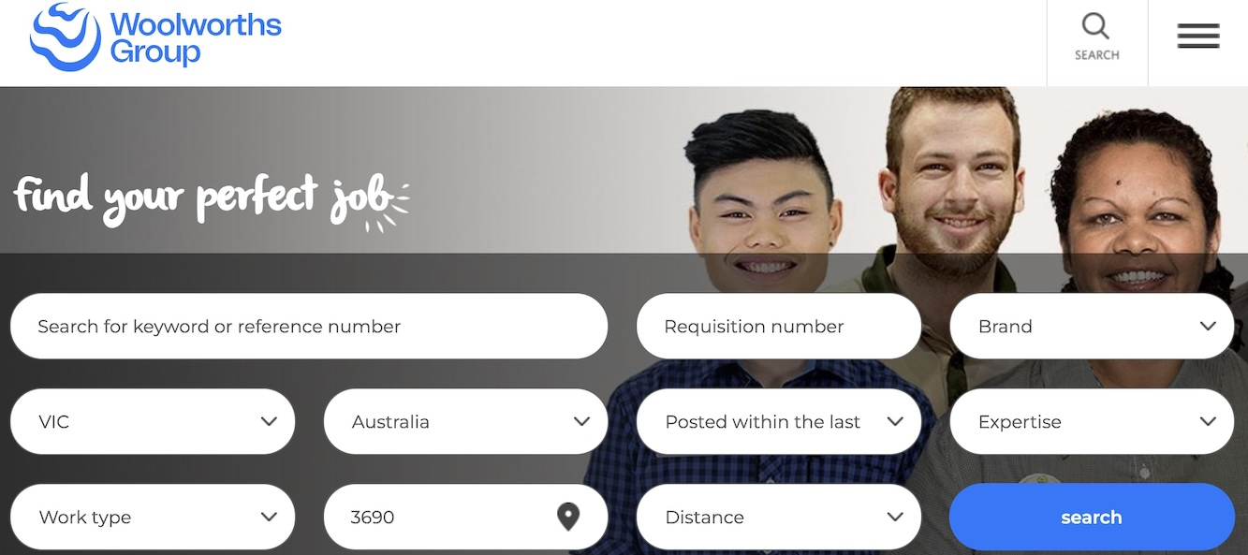

McDonalds

On this webpage, you can research the types of jobs available at Maccas and the recruitment process, https://careers.mcdonalds.com.au/ Click the ‘join our crew’ link to search for jobs and start the application process.

KFC

On this webpage, you can search for jobs and start the application process, https://careers.kfc.com.au/ You can also learn about the different jobs available at KFC.

Bakers Delight

On the Bakers Delight careers page, you can search for jobs and also complete an expression of interest profile. You will need to upload your resume and a cover letter when completing the expression of interest form. Select the casual and part time sales assistant roles when using the job search filter, www.bakersdelight.com.au/company/careers

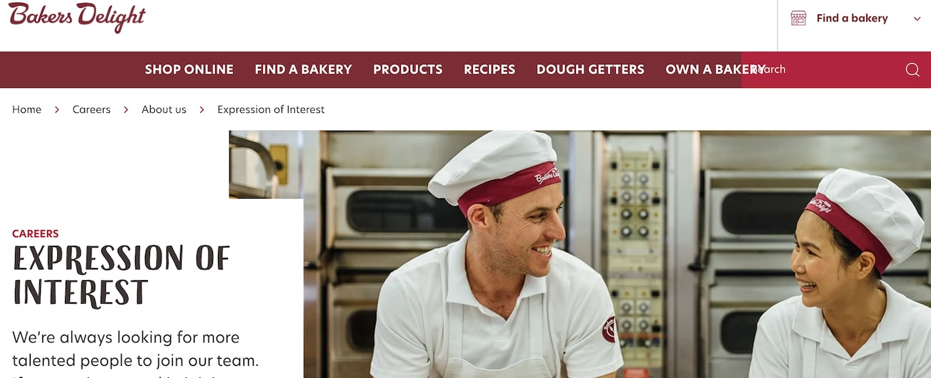

Muffin Break

Muffin Break

If you’d like to work for Muffin Break, drop a resume and cover letter into your local store. Ensure you read about the recruitment process on the Muffin Break website so you can prepare what information to place on your cover letter, https://muffinbreak.com.au/careers/

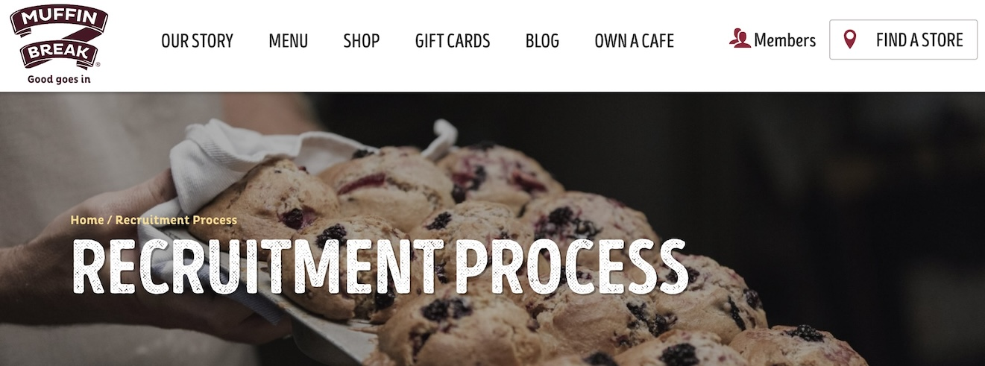

Careers Coordinator: Mrs Laura Lunardi

Kmart Group

Kmart: to work at Kmart, read about the recruitment process via https://jobs.kmart.com.au/KMARTAUNZ/ You can search for jobs and apply via this page.

Target: to work at Target, read about the recruitment process at this page - www.target.com.au/our-company/careers You can complete an expression of interest for jobs on this page and create a profile. Target may reach out to you to organise an interview based on what information you put into your profile. Ensure you keep your profile up to date to have the best chance of being shortlisted for an interview.

Boost Juice

On the Boost Juice careers page, you can complete an online expression form, and this will connect you with stores in your area. You can also drop in your resume and a cover letter to stores. Visit https://www.boostjuice.com.au/work-at-boost/



