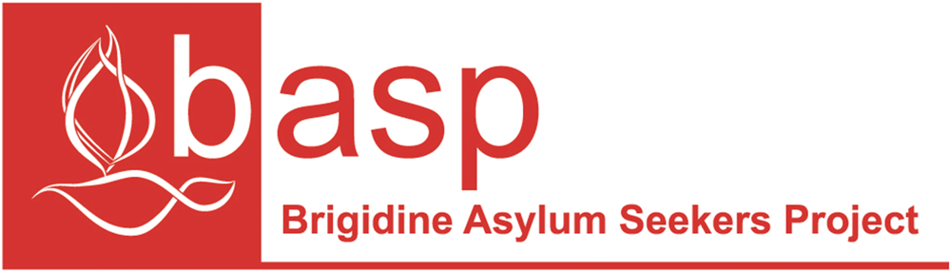

BASP is an initiative of the Brigidine Sisters, established in 2001.

It was established to work for a humane, just and inclusive approach for people seeking asylum in Australia.

**What they do:**

* Provide hospitality and practical support for people seeking asylum
* Actively network with like-minded individuals and groups who are working for justice for asylum seekers
* Promote advocacy for the rights of people seeking asylum
* Engage in education about asylum seekers issues.





**BASP Winter Food Drive**

**Items to bring:**

* Sugar
* Flour
* Cooking oil
* Can of tomatoes, fruit, tuna, red kidney beans, corn or peas
* Long life milk
* Tea
* Coffee
* Shampoo
* Conditioner
* Shaving cream
* Toothpaste
* Washing powder
* Dishwashing detergent
* Other cleaning detergents
* Gladwrap
* Tinfoil
* Pegs
* Disposable nappies
* Wipes

**Please bring all items in by Thursday the 22nd of June**